# Backstage Integration with Software Catalog and Template

The Software Catalog is available to browse at /catalog, you should be able to browse the cata-log at <http://localhost:3000>.

Adding components to the Catalog

The source of truth for the components in your software cata-log are [metadata YAML files](https://backstage.io/docs/features/software-catalog/descriptor-format) stored in source control (GitHub, GitHub Enterprise, GitLab, ...).

We’ve registered components manually here.

Users can register new components by going to /create and clicking the **REGISTER EXISTING COMPONENT** button:

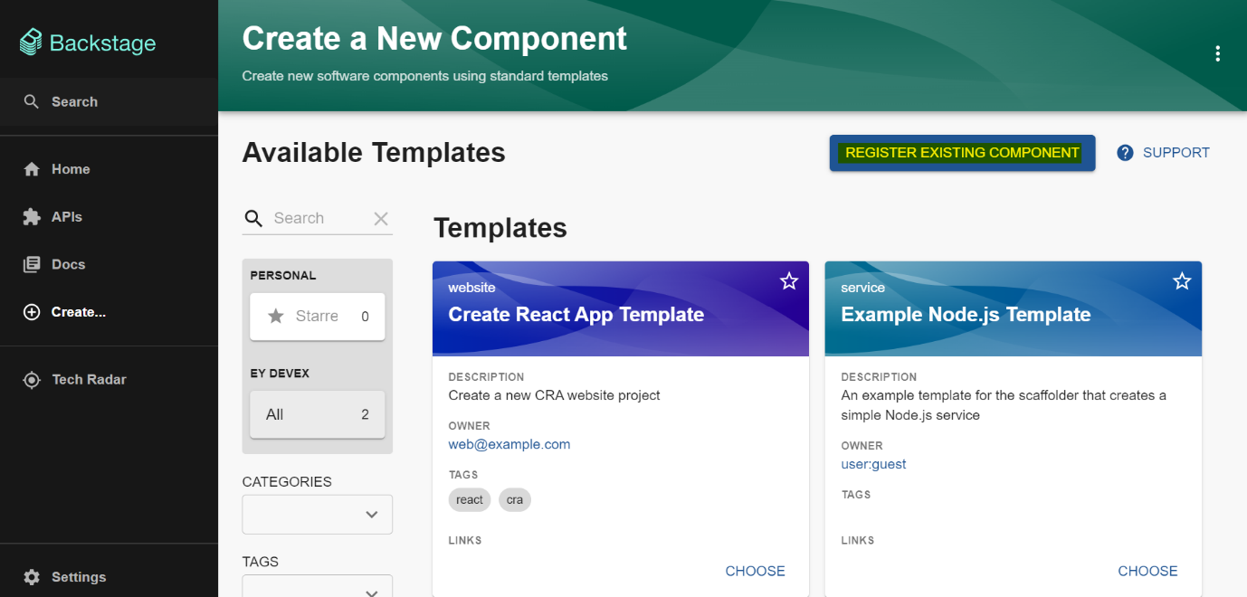

Provide the github URL- of the repo's **catalog-info.yaml** file

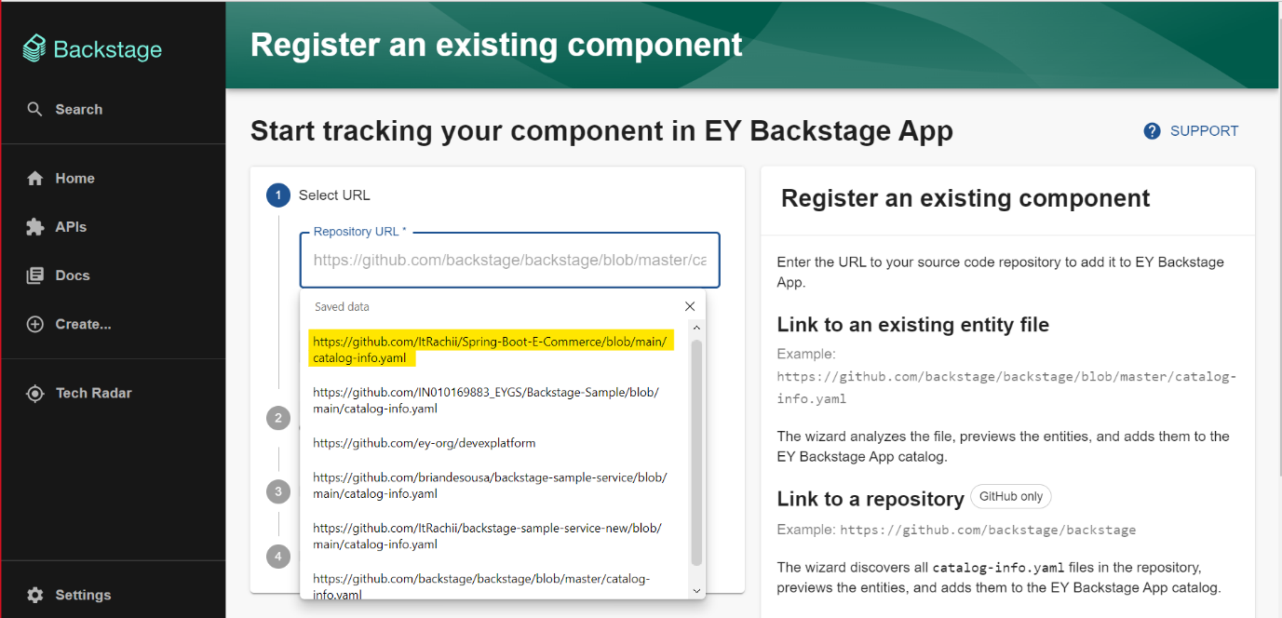

Click on "**analyze**" button.

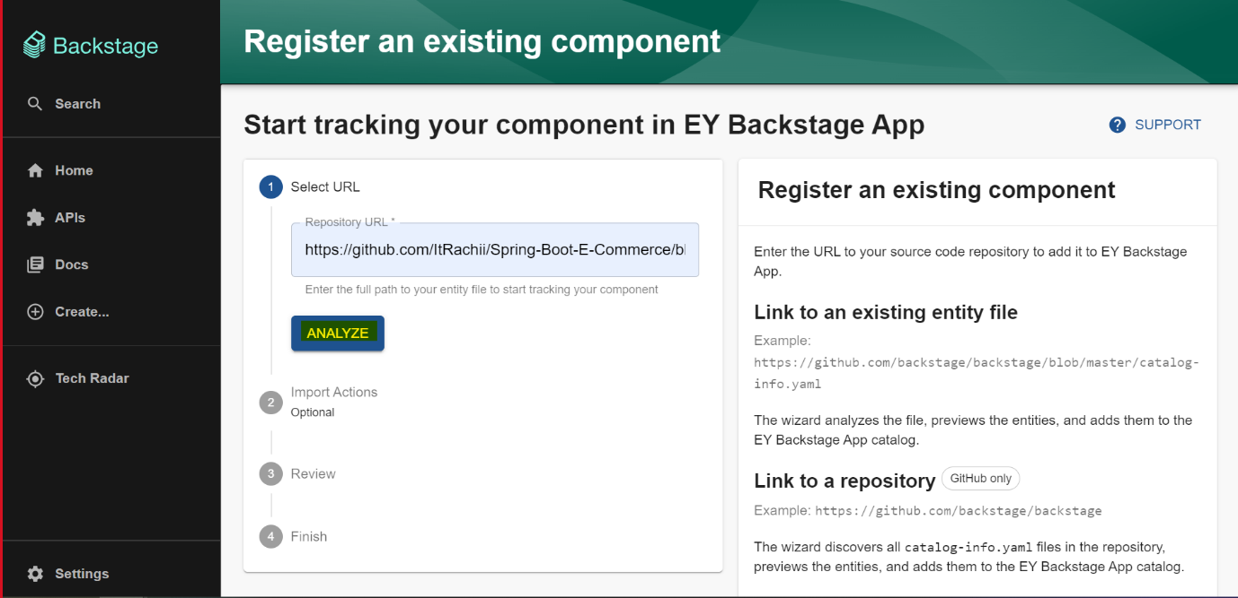

Once reviewed click on "**import**" button to add the component to your backstage application.

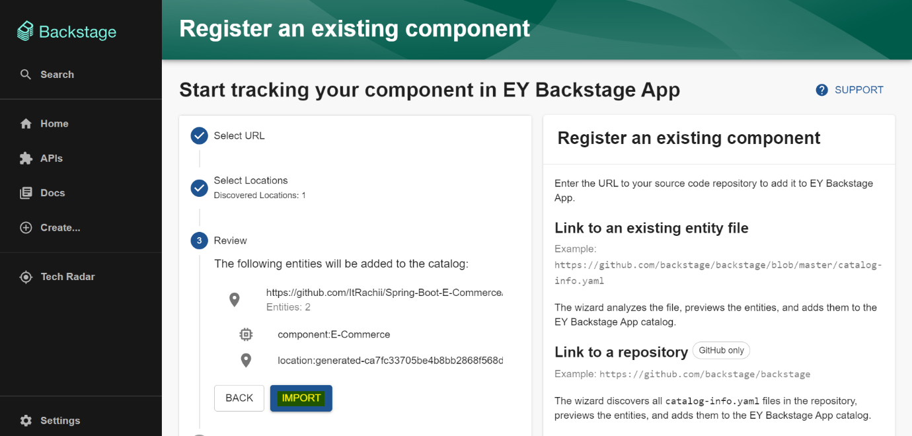

Click on the highlighted hyperlink to view your newly imported component.

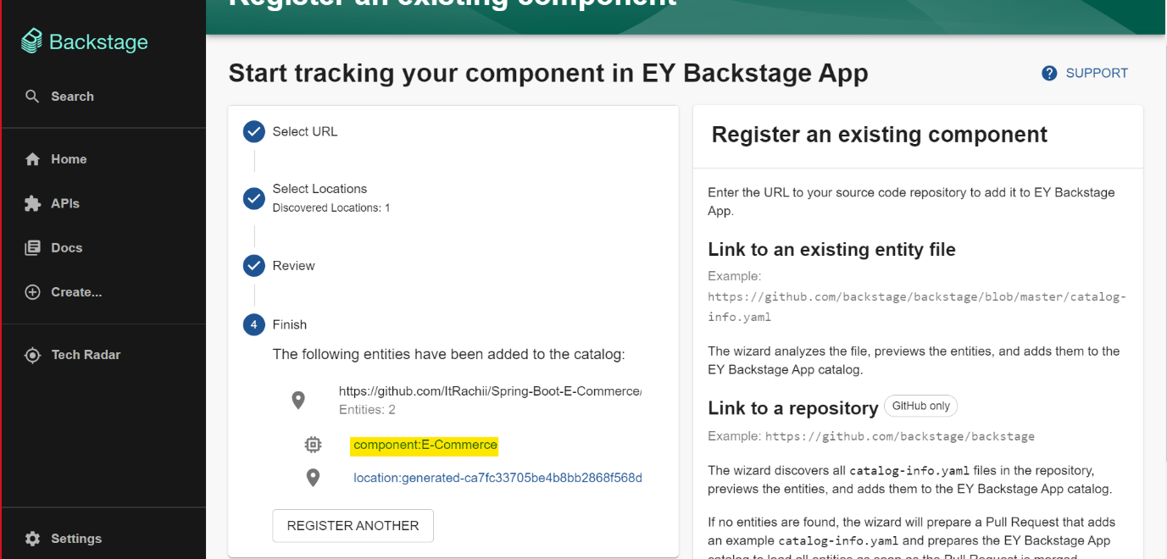

Creation of templates

For creating templates, first we need to modify some changes in **examples** folder directory in backstage directory. And then create a new custom-template folder directory in it.

Creating react-app : Create two files in custom-folder directory : **skeleton , template.yaml**

**Skeleton keeps all your source codes and also contains catalog-info.yaml file.**

**template.yaml**

**Code:**

apiVersion: scaffolder.backstage.io/v1beta3

kind: Template

metadata:

name: create-react-app-template

title: Create React App Template

description: Create a new CRA website project

tags:

- react

- cra

spec:

owner: web@example.com

type: website

parameters:

- title: Provide some simple information

required:

- component_id

- owner

properties:

component_id:

title: Name

type: string

description: Unique name of the component

ui:field: EntityNamePicker

description:

title: Description

type: string

description: Help others understand what this website is for.

owner:

title: Owner

type: string

description: Owner of the component

ui:field: OwnerPicker

ui:options:

allowedKinds:

- Group

- title: Choose a location

required:

- repoUrl

properties:

repoUrl:

title: Repository Location

type: string

ui:field: RepoUrlPicker

ui:options:

allowedHosts:

- github.com

steps:

- id: template

name: Fetch Skeleton + Template

action: fetch:template

input:

url: ./skeleton

copyWithoutRender:

- .github/workflows/*

values:

component_id: ${{ parameters.component_id }}

description: ${{ parameters.description }}

destination: ${{ parameters.repoUrl | parseRepoUrl }}

owner: ${{ parameters.owner }}

- id: publish

name: Publish

action: publish:github

input:

allowedHosts:

- github.com

description: This is ${{ parameters.component_id }}

repoUrl: ${{ parameters.repoUrl }}

- id: register

name: Register

action: catalog:register

input:

repoContentsUrl: ${{ steps.publish.output.repoContentsUrl }}

catalogInfoPath: "/catalog-info.yaml"

output:

links:

- title: Repository

url: ${{ steps.publish.output.remoteUrl }}

- title: Open in catalog

icon: catalog

entityRef: ${{ steps.register.output.entityRef }}

The above **template.yaml and skeleton** files can also be seen through the given link :

https://github.com/backstage/software-templates/blob/main/scaffolder-templates/create-react-app/template.yaml

After adding these two files modify app-config.yaml file by adding the following line shown in picture :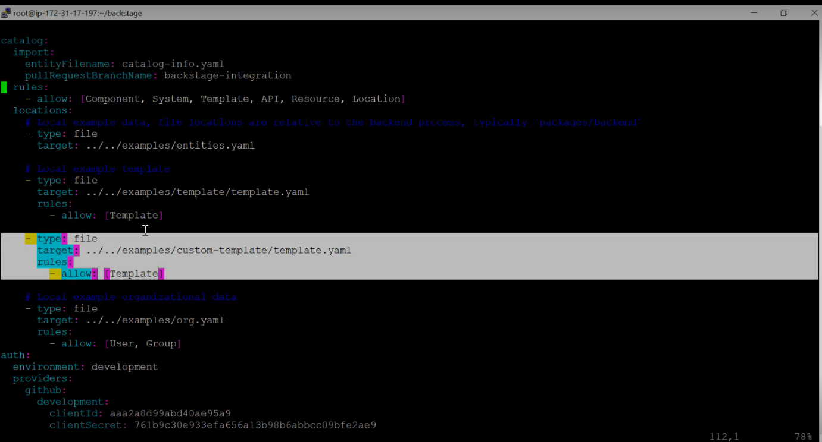

Restart the application and click on "**create**" button.

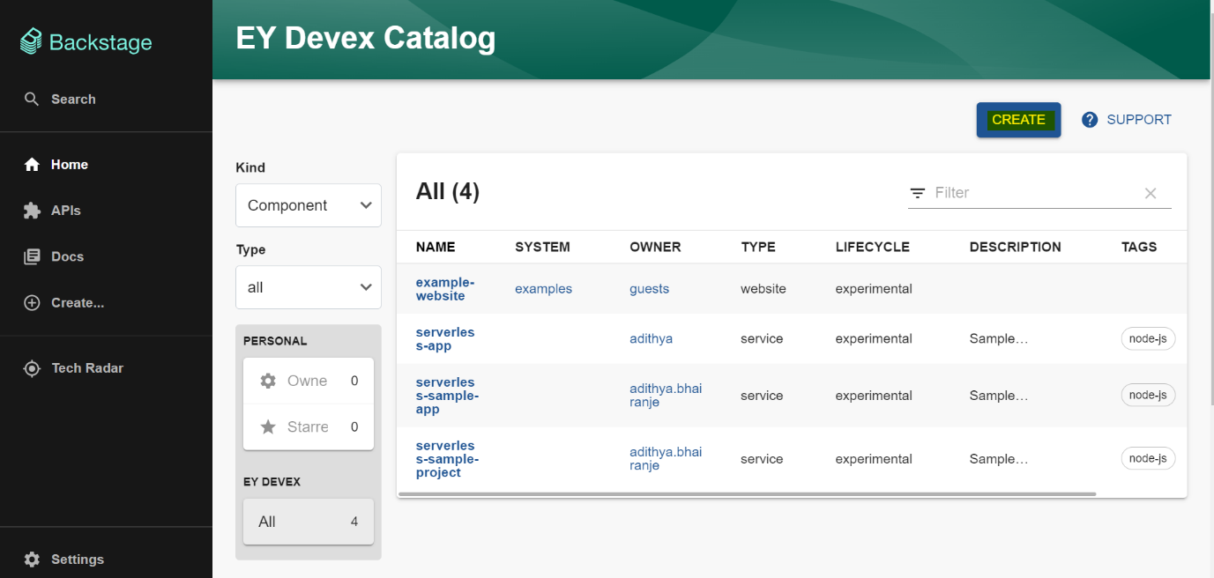

New template is now available.

